Breaking the road barrier—saving animals and humans
The upgrade of a small section of a Brisbane road from two to four lanes captured few local newspaper headlines when it was announced, but 10 years later, the research it spawned reverberates around the world.

The Compton Road upgrade was similar to countless road-widening construction projects except for one major difference—the innovative approaches to reduce road kills and assist animals trying to traverse the road barrier as well as reducing the potential for fatal motor vehicle accidents from collisions with animals.

Griffith University's Professor Darryl Jones is an expert in urban ecology and wildlife management. For more than a decade he has been at the forefront of world-leading strategies to keep people safe as well as protect wildlife, road ecology and road safety.

Professor Jones is a driving force behind developing wildlife road crossing structures that have set the standard for best practice in road engineering.

This leadership has ignited a world-wide revolution in the way we develop and connect our communities in environmentally sound ways.

"Compton Road works better than anyone expected, including myself," Professor Jones said.
The purpose-built structures and research findings from the 1.3 km upgrade are changing road ecology practices around the world.

The Compton Road fauna overpass is the world's most studied overpass, with ongoing research providing a wealth of information on best practice road permeability methods to manage wildlife, as well as a greater understanding of fauna behaviour, home ranges and seasonal movements.

Prior to the Compton Road project the goal of reducing road kill was accepted by all as worthy but there were no proven measures or design considerations that protected wildlife.

"Now, no one can claim that there is no evidence that it works," Professor Jones said.
"It has led to an absolute transformation in the way that all the roads, just about anywhere in Australia, are conceived."

The great divide

Roads are ubiquitous in the modern urban landscape. They largely define where people live and provide the means for connecting them with almost every aspect of daily life. However, the road toll is a devastating consequence of this convenience.

For wildlife, rather than linking communities, roads fragment the landscape and present physical barriers to movement and disrupt much-needed gene-flow.

"The first principle of road ecology is how can we overcome the road barrier for animal movement with a structure of some sort," Professor Jones said.

"Keeping animals off roads is vital for everyone's safety.

"Of course you can just put up fences but it is very important that the ecosystem being divided is still able to function; that the animals can cross freely between areas of land separated by the road. When animals become stranded in smaller, isolated pockets, the chances of them going extinct are much greater.'

While wildlife deaths are evident by the all-too-common sight of carcases on roads, this reduced biodiversity had, until recently, often been accepted as an unavoidable cost of urban inroads into the natural home ranges of a myriad of wildlife.

In 2003 that all changed when Brisbane City Council decided it wanted to change the status quo and take a more sustainable approach to development.

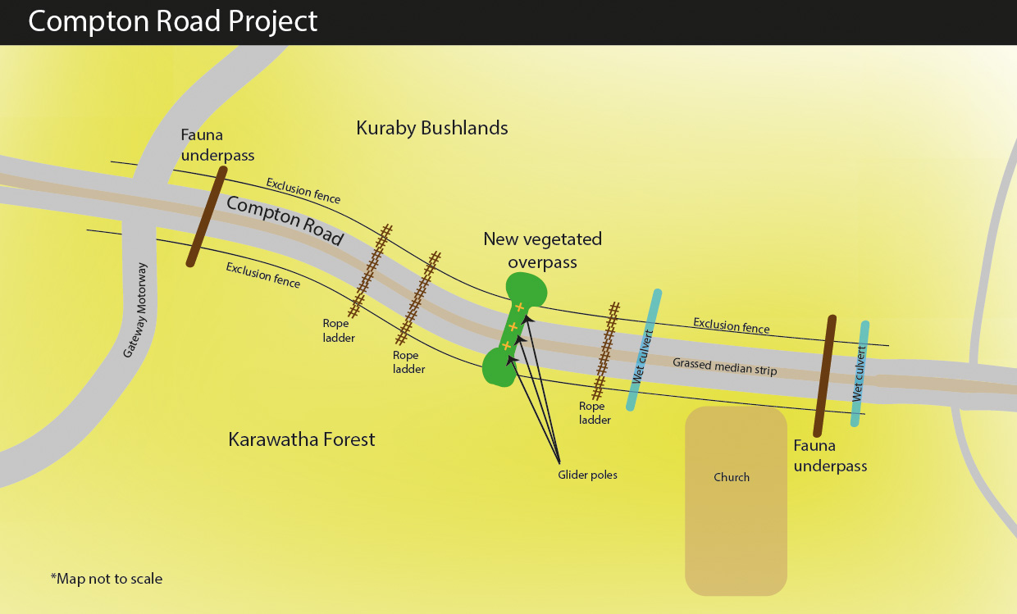

The Compton Road project

The upgrade of a1.3 km section of Compton Road—a major east-west arterial road in the southern suburbs of Brisbane—from two to four lanes was the unexpected catalyst for road ecology change.

This road cuts through Karawatha Forest, one of the largest areas of remnant bushland within the region, and one that had only just been recognised as being of national significance.

"Surveys of the surrounding bushland along Compton Road had identified 95 species of birds in the area, eight of which were locally significant," Professor Jones said.

"There were also 18 species of mammals recorded, 10 of which were of significance, including eastern grey kangaroo and three species of gliders."

Lord Mayor Jim Soorley approved the road upgrade but also set the challenge that, as much as possible, both road users and local wildlife were to be protected. Professor Jones was asked to lead the ambitious project.

"We realised a great deal of work had been going on in Europe where it is legislated that if you build a road you have to incorporate features such as animal overpasses, big grassed-over mounds allowing larger animals to cross safely over the road.

"There are hundreds of these crossing structures across Europe and you can understand why. Let's face it, you really don't want to hit a deer on the German autobahn when you are doing 130km/h."

But there was some scepticism about how European features such as wildlife bridges and badger tunnels under roads might be applied here. Despite that, what was proposed for Compton Road incorporated not just a wildlife overpass but also rope ladders for possums, poles for gliders and customised culverts to act as tunnels for small animals to pass beneath the road.

All roads have culverts, which run alongside and underneath to drain water away. In dry times animals can use these culverts as tunnels, but what was proposed as part of the Compton Road upgrade were specially constructed ones that wouldn't fill up with water so animals could pass through them all the time.

The game changer

While that was innovative, the key to Compton Road's success was that it was more than just a big, mounded overpass; it was also heavily planted with locally sourced vegetation to become a continuous strip of the surrounding forest.

"Compton Road land overpass was intentionally built to replicate the habitat on either side," Professor Jones said.

"Ours is just like a forest, which is what the birds and the bats and mammals and everything else think as well. We do it quite differently to other countries, and we were able to explain vegetation really makes a difference to other animals.'

That was the ground-breaking difference that has proven so successful and is the model now copied around the world.

Windfall out of adversity

As part of the Compton project, a fence was erected along both sides of the road.

"It was hoped that once the disruptive construction work was finished, smaller animals would begin using the tunnels and the bigger animals go over the top," Professor Jones said.

"The nagging concern was how long would it take for the animals to come back once the construction was completed."

Help came from an unexpected quarter.

In 2005, when landscapers began planting thousands of little plants from the local area on top of the completed overpass, the entire region was suffering from severe drought.

In order to keep the plants alive, a trickle irrigation system was set up using water from a reservoir within the forest.

"There was dust everywhere but that actually worked in our favour. From the animals' perspective, suddenly there was a big mound with lush green vegetation on the top. So wallabies, kangaroos, possums, all the animals we wanted to use this feature were drawn there almost immediately," Professor Jones said.

"Now 10 years down the track we have large trees growing on the place.

"These trees have replaced the need for the initial glider poles which are now dwarfed.

"There are also management issues. If you are going to make an ecosystem that functions and grows and gets bigger you have to deal with that at some stage."

Footprints of success

To see if the underpasses were working, Brisbane City Council installed cameras and sand was laid to record tracks.
"Just six months after completion, we were absolutely overwhelmed by how many animals were there," Professor Jones said.
"On the busiest nights in summer we had 45 animals using all the crossing installations. Even little animals, which had never seen a structure like it before, were scurrying through an 80-metre tunnel. And so we had incredible evidence that all this worked."
And then things started happening that no one had expected.
"Once the vegetation was fully established with trees and shrubs growing over the top of the overpass, birds started using it in an enormous way," he said.
"People said: 'Birds? But birds can fly. Why do they need an overpass?' But little birds such as robins or fairy-wrens won't fly across 120 metres of busy traffic.
"It was a fairly big revelation that little birds don't fly over roads. It's not because of traffic or noise, it's simply the space from one side to the other.
"For a little bird to fly 40 metres across a road it is too dangerous, it doesn't fly very far. A little bird flies two metres from one bush to another. Putting in these vegetated overpasses has linked up populations, which had been severed when roads were first put in.
"It's really important stuff in terms of conservation biology."
And then the little bats arrived.
"Microbats will fly up and down either side of a road but they will not fly across one. At Compton Road, they now fly up to the crossing, over the vegetation bridge and down to the other side."
Once the vegetation was fully established several species of animals began living and breeding on the overpass including red-necked wallabies and hares, as well as 13 species of reptiles and frogs. It had become a fully functioning ecosystem in its own right.
This overwhelming success triggered a world-wide revolution in road ecology.
"They are vegetating overpasses in Europe in a big way now. In fact there are several experimental overpasses in Sweden directly replicating Compton Road," Professor Jones said.
“The wildlife structures at Compton Road cost $700,000, which back in 2005 was a significant sum, but to put that into perspective, it was just 1.5% of the overall cost of upgrading the road.
"Before the crossing structures were installed there was, on average, 14 wallabies and three koalas killed each year. In the entire decade since then, and despite the volume of traffic having more than doubled, just three wallabies have been killed and that was only because someone cut a hole in the fence."

Counting the costs

Nationally, damage from collisions with kangaroos and wallabies is estimated at tens of millions of dollars by NRMA Insurance, while road fatalities caused as a direct result of either a collision or from motorists swerving to avoid animals are numerous.
In the 10-year period 1996–2005 the NSW Roads and Traffic Authority Traffic Accident Database recorded a total of 13 people had died from motor vehicle collisions with kangaroos or wallabies in NSW. It also recorded one death from an impact with a wombat on a road over the same period.
The Authority recorded 5,119 reported crashes involving animals (including livestock and domestic animals) over the 10-year period. Included were 2097 collisions with kangaroos or wallabies, 149 with wombats and 30 with emus.
However, there may be more because not all animal collisions were reported and there may not have been witnesses to fatal accidents caused when motorists swerved to avoid animals.

Saving our iconic cuties—koalas

Following the success of the Compton Road project, Professor Jones was asked to turn his expertise to a new problem: koalas. In 2009 and 2010, koala numbers were in serious decline in South East Queensland. Roads were the number one cause of death, followed by dogs and disease.
The Queensland Government commissioned a $2.3 million study focussed on minimising the impact of roads on koalas.
"We identified eight sites where koalas were being run over and there were good populations either side of the road that should remain connected," Professor Jones said. "But an overpass takes months to construct so it can only be done on a new road or like Compton Road where a massive upgrade was taking place.
"More significantly, koalas don't like being in the open, so an overpass wasn't a suitable idea anyway. We thought a tunnel might work as koalas are nocturnal and so being inside a dark tunnel shouldn't be an issue, but all the under-road culverts were full of water.
"I had just come from a conference in Europe where I learned that otters will not swim under a bridge more than two lanes wide. They will get out of the water and attempt to walk across the road and down the other side to get back into the water. However, it had been discovered that otters will walk along a ledge under the bridge.
"I had noticed that some of the culverts near koala habitats were large and even though there was water in them, I thought a ledge above the water line might work.
"I was incredibly sceptical. I'm their greatest fan but they're not smart animals, not what you would call innovators."
However, just three weeks after six existing drainage culvert structures were retrofitted with ledge-like pathways and fauna-proof fences, seven separate koalas in their vicinity were spotted using the underpasses attempting to access other bushland areas.
Across the two-year study more than 60 koalas living in the vicinity of six fauna-crossing structures were fitted with radio tracking collars to track their movements and use of the structures.
Check here

"A ledge costs around $5000 which is far cheaper than an overpass structure and it's very effective," Professor Jones said.

"There are now around 70 of them around South East Queensland and they have become a key asset for sustainable development.

"Retrofitting is all the go. It's a fairly simple, cheap easy solution that can be applied just about anywhere.

"As soon as we put up the fence so they could not get on the road, the koalas were using them straight away.

"No koala in evolutionary history had ever had to do it but they did it because their yearnings were such that they wanted to get to the other side of the road."

The fact that koalas are an iconic Australian animal also helped in their conservation.

"Koalas get the attention because they are listed as endangered animals and it also just so happens we have the cutest, most iconic mammal living among us," he said.

"Under Federal law any new development that is potentially going to disrupt koala habitat must have mitigation measures included in the plans. So in many areas developers are now putting in ledges.

"The koala project is really an extension of the earlier work we did with Compton Road. What we have been able to demonstrate absolutely is that if animals are provided with a means to move safely they will use it.

"And because of our work, no one anywhere in the world, can say it can't be done."

The Compton Road effect

While new road constructors may not have visited the Compton Road project, they know of its name and its impact on their designs.

"Queensland's Transport and Main Road Department has a Road Sensitive Design Manual and it's available to every road constructor in Queensland. It is used around Australia and our specifications and findings are all through that," Professor Jones said

"While it is not mandated by legislation it still happens. Developers have to show how the new road will improve the permeability to the environment on the site—all have to have underpasses.

"Every big road, every major road, and every motorway in Queensland now has underpasses.

"As a result, every time there is a new road we often get asked to help either design it or monitor it."

The guide is continually updated by the Griffith team's research as they discover better ways to protect wildlife and enhance movement of fauna.

The unique design of the wildlife-exclusion fence, known as a Compton Road Fence, is now standard in the development and major road construction industry.

The design incorporates measures to block small mammals, lizards, amphibians attempting to access roads as well as metal sheet strip to stop climbing animals. It also includes escape measures for small terrestrial species that find themselves on the roadway side of the fence.

New research to give deeper understanding of fauna habits

The initial success of the Compton Road project has prompted a range of research beyond that of road ecology.

"What does 'use' mean - that's a really topical point for us scientifically," Professor Jones said.

"When we first started doing this we thought: Will the animals use the structures? So, we were really thrilled when we got detection of animals walking through it.

"Now, much further down the track, we are asking who are the animals using it? Are the same animals using it? Are they going back and forth each day? Are they territorial animals preventing other animals going through it?

"We're getting really detailed work on that.

"There has been so much interest in koalas we were able to put in personalised tags so we can detect individuals and what time of the night they went through the tunnels."

However, the impact of the research is not limited to roads. Professor Jones' team are just beginning one of their biggest research projects with the Moreton Bay Rail Extension Project.

The project traverses a number of sensitive environmental areas with the rail line posing similar barrier problems for animals and requiring effective crossing structures.

"The same principles apply for roads as they do to rail lines."

Professor Jones' research group is now the most active and accomplished scientific team working with road agencies and consultancies on all aspects associated with the design, monitoring and evaluation of fauna-friendly roads and crossing structures throughout the country.

He attributes part of the group's success to being involved from day one with the Compton Road project.

"The research group was involved in the design right from the beginning, but also the research group was at the beginning of this field, when the field really started and they are all keenly invested in it," Professor Jones said.

"The fact that the research group is close to the overpass is really handy. Compton Road's right on our doorstep."

The research team has just finished a 10-year review of the Compton Road project. Not even Professor Jones could have imagined the huge impact his research on this 1.3 km stretch of road would have on urban ecology and animals throughout the world.

"Now there are animals there, a dozen generations of animals that have grown up with those structures as part of their normal environment," he said.

"When they first went in they were completely new to those animals and there had been a huge amount of noise.

"Now it is a completely normal part of their environment. No one can say it can't be done."

